**CLOUD COMPUTING**

Name: Siri Gowri H

SRN : PES1UG21CS599

Sec. : J

**Experiment 2: - Introduction to AWS S3 (Simple Storage**

**Service) and Hosting a Static Website Using Amazon Simple**

**Storage Service**

**Screenshots:**

1. **Bucket Creation**

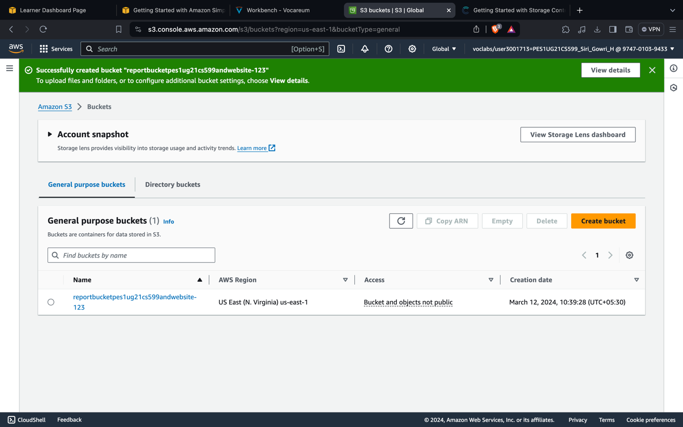

**2.403 Forbidden Error page for clicking the website link**

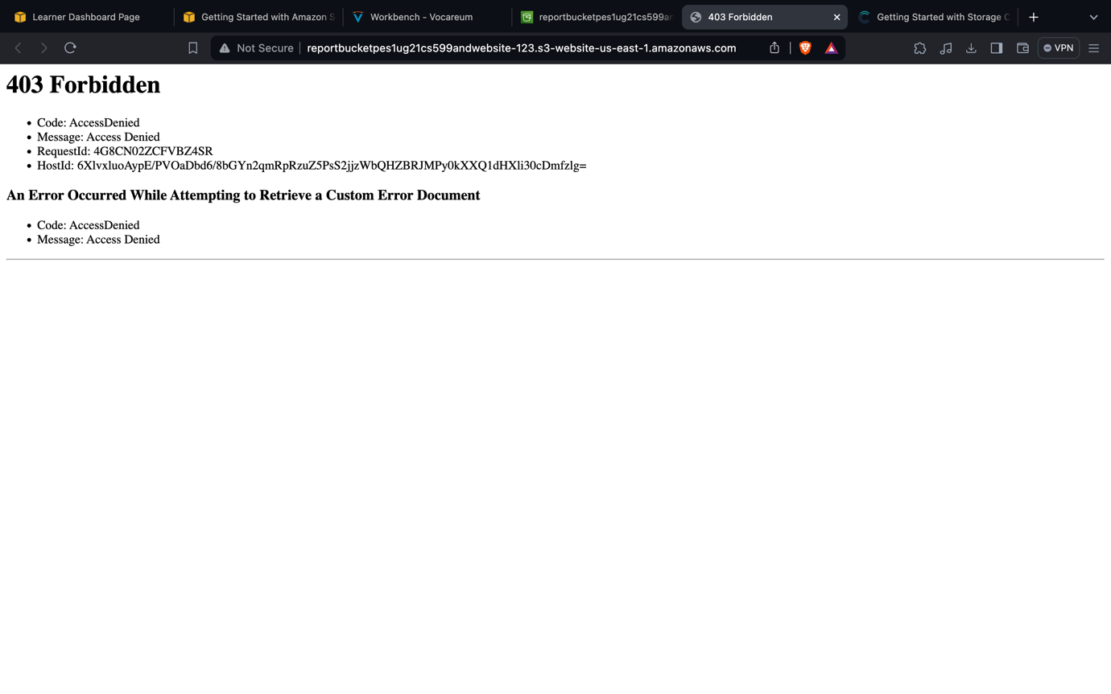

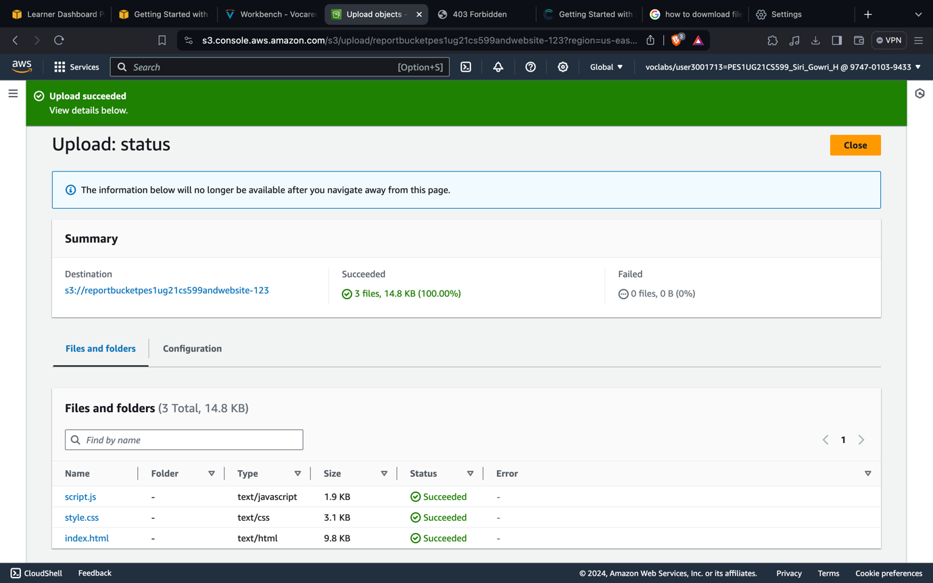**3.Uploading the contents to the bucket**

**4.Static website before modifying index.html file**

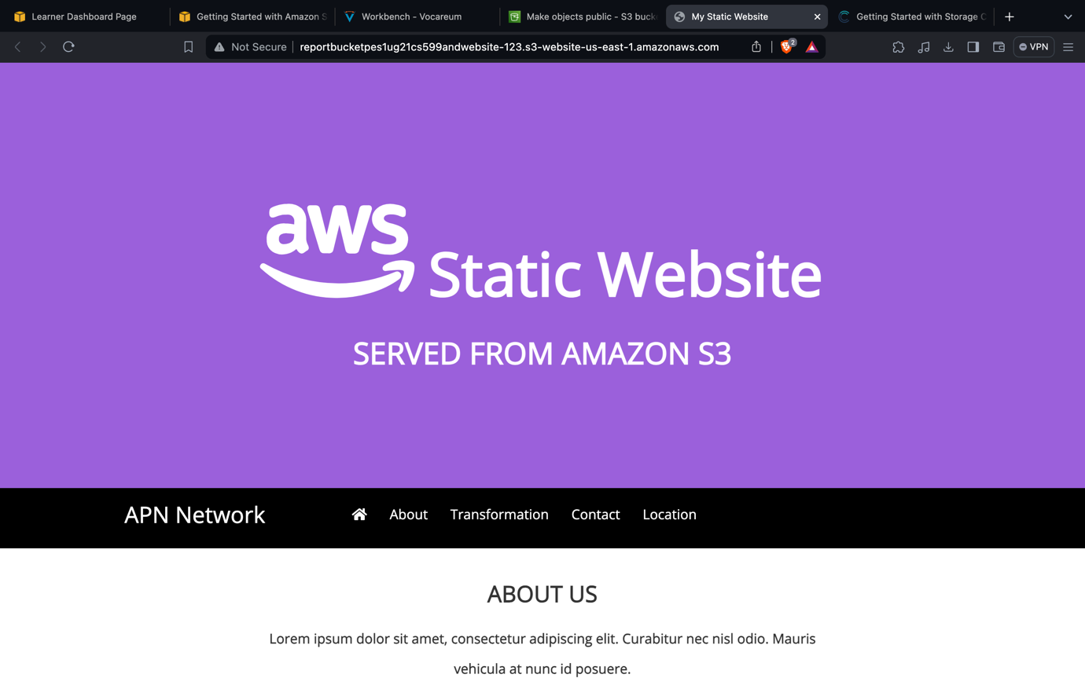

**5.Pasting the Pre-signed link**

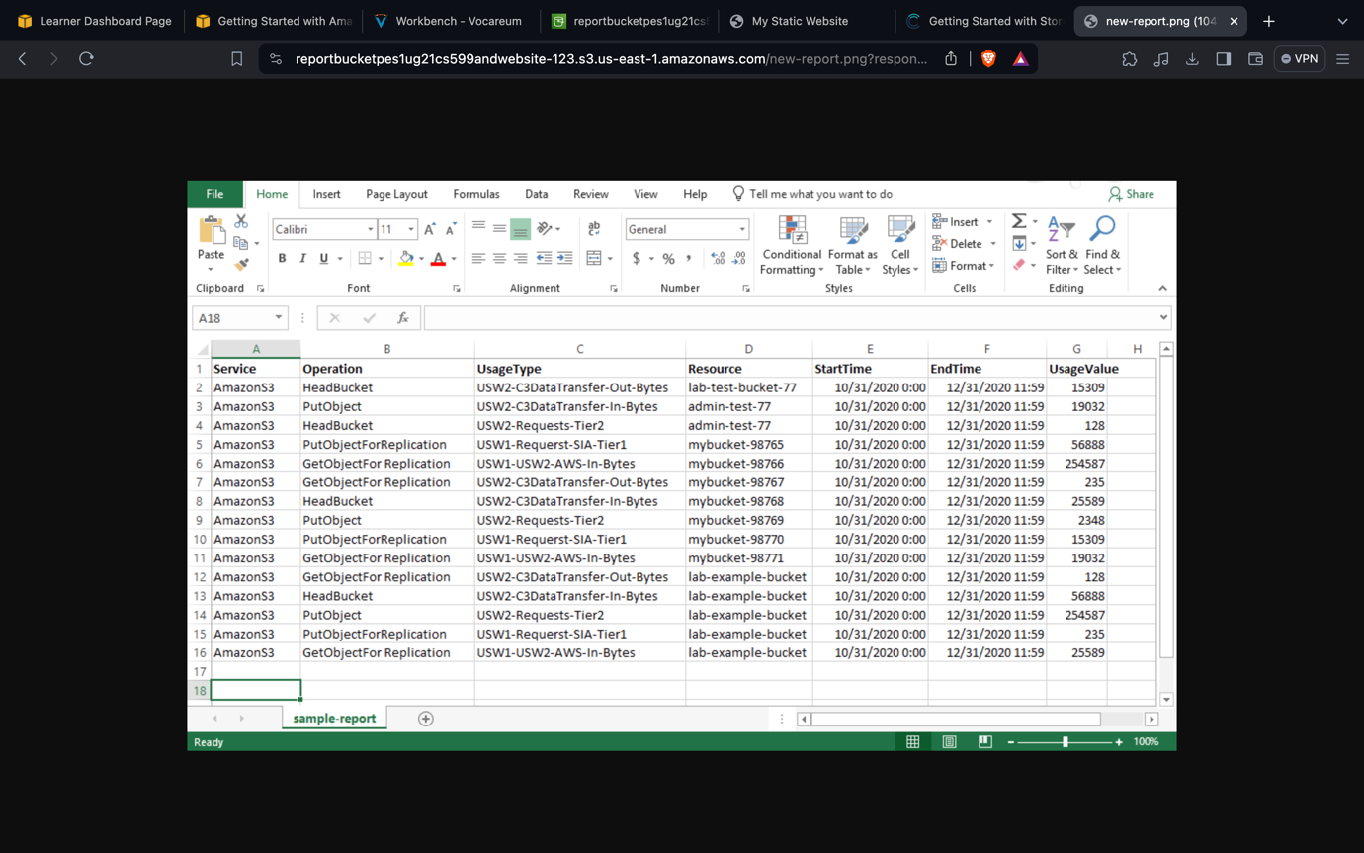

6.**Static website after modifying index.html file**

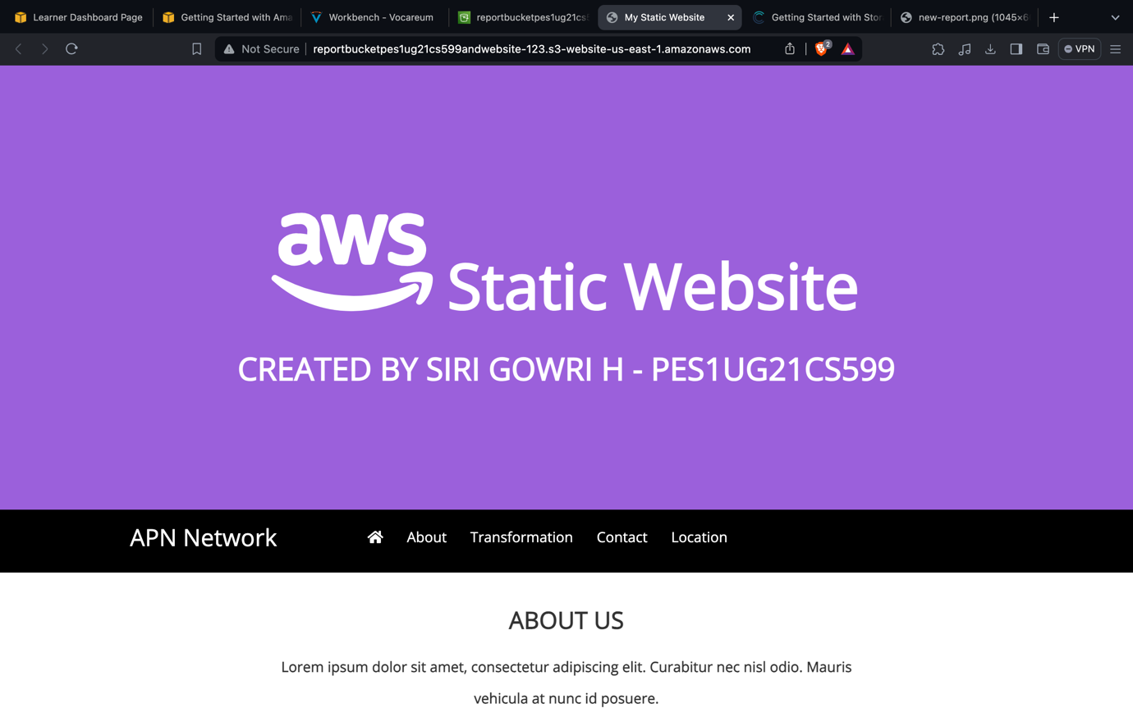

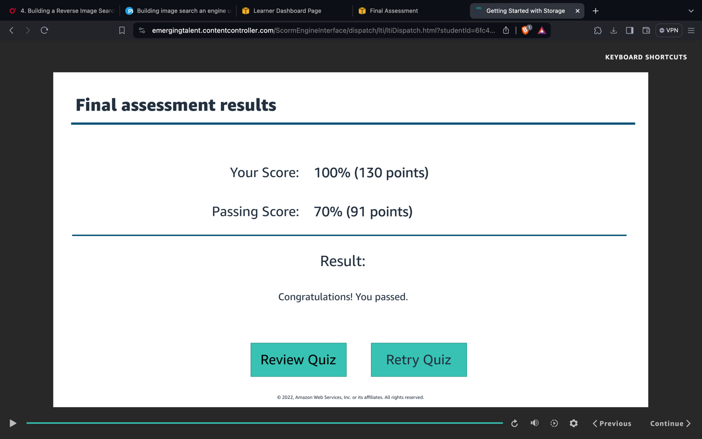**7. Test**